AP Environmental Science Ch. 9
Sustaining Biodiversity: Saving Species and Ecosystem Services

Core Case Study: Where Have All the Honeybees Gone?
- Bees play a key role in _______________
- Globally, about one third of the __________ __________ comes from insect-pollinated plants
- Currently, agriculture depends heavily on a __________ species of bee
  - Suffering from Colony Collapse Disorder
    - Each year, __________ of colonies in Europe and the U.S.
9-1 What Role Do Humans Play in the Loss of Species and Ecosystem Services?
- Species are becoming extinct _____ to _____ times faster than they were before modern humans arrived on the earth
  - By the end of this century, the extinction rate is expected to be _____ times higher than that background rate
Extinctions Are Natural but Sometimes They Increase Sharply
- __________ extinction
  - No species member alive
- Trophic __________
  - Population declines or extinctions among connected species
- __________ extinction
  - Many species in a short amount of time
Some Human Activities Hasten Extinctions and Threaten Ecosystem Services
- __________ extinction rate
  - 1 extinct species / year / 1 million species
- Extinction rates have __________ recently
  - Current extinction rate is at least _____ times higher than typical background rate of 0.0001%
- Rate of extinction and threats to ecosystem services likely to rise sharply in the next 50-100 years
  - Due to harmful __________ impacts
- Biodiversity __________
  - Extinction rates projected to be much __________ than average
- Biologically diverse environments are being eliminated or fragmented
Endangered and Threatened Species Are Ecological Smoke Alarms
- __________ species
  - So few members that the species could soon become extinct
- __________ species (vulnerable species)
  - Still enough members to survive, but numbers declining
  - May soon be endangered
- __________ extinct
  - In areas a species is normally found
- __________ extinct
  - To the point at which species can no longer play a functional role in the ecosystem
9-2 Why Should We Care about the Rising Rate of Species Extinction?
- We should avoid speeding up the extinction of wild species because:
  - Of the ecosystem and economic services they provide
  - It can take __________ of years for nature to recover from large-scale extinctions
  - Many people believe that species have a __________ to exist regardless of their usefulness to us
Species Are a Vital Part of the Earth’s Natural Capital
- Major reasons to prevent extinctions
- Species provide vital __________ services
  - Help keep _____ alive and support our economies
- Many species also contribute economic services
  - __________ for food, fuel, lumber, and medicine
  - _______________
- It will take __________ million years to regain species biodiversity after this century’s extinctions
- Many people believe species have an __________ right to exist
- How do we decide which species to protect?

9-3 How Are We Threatening Species and Ecosystem Services?
- The greatest threats to any species are (in order):
  - Loss or degradation of its __________
  - Harmful __________ species
  - __________ population growth
  - __________
  - Climate change
- ____________________
Loss of Habitat Is the Single Greatest Threat to Species: Remember HIPPCO
- Habitat destruction, degradation, and fragmentation
- Invasive (nonnative) species
- Population and resource use growth
- Pollution
- Climate change
- Overexploitation
  - Habitat fragmentation
    - Large intact habitat __________ by roads, crops, and urban development
  - National parks and nature reserves as habitat __________
We Have Moved Disruptive Species into Some Ecosystems
- Many species introductions are __________
- __________ species may have no natural:
  - Predators, competitors, parasites, pathogens
- Nonnative species can crowd out __________ species
- Invasive species
Case Study: The Kudzu Vine and Kudzu Bugs
- Imported from Japan in the 1930s
  - Help control soil erosion
- Very difficult to kill
- Could there be benefits of kudzu?
- Kudzu bug – imported from Japan
  - Can kill Kudzu vine
  - Also kills soybeans
Some Accidentally Introduced Species Can Disrupt Ecosystems
- Argentine fire ant – introduced in the _____
  - Reduced populations of native ants
  - Painful stings can kill
  - Pesticide spraying in _____ and _____ worsened conditions
  - Tiny parasitic __________ may help control fire ants
Case Study: Burmese Pythons Are Eating Their Way through the Florida Everglades
- __________ introduced
- Reproduce rapidly and are hard to kill
- Greatly depleted _______________ populations of:
  - Rabbits, foxes, raccoons, opossums, and deer
Prevention Is the Best Way to Reduce Threats from Invasive Species
- Research programs identifying invaders
- Establishing international treaties banning transfer between countries
- Public education about exotic pets and plants
- What else can be done to prevent invasive species?

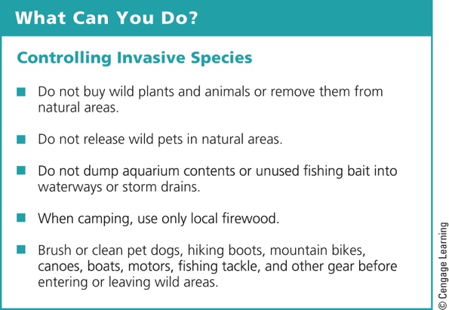

Other Causes of Species Extinctions
- Human population growth and overconsumption
  - Degrading habitat
- Pollution
  - ____________________ can cause extinctions of species not directly affected by pollution
- Climate change
  - Some species will become extinct, some will spread
Case Study: Polar Bears and Climate Change
- Live only in the Arctic
- Arctic ice is melting
  - Decreasing polar bear habitat
  - Polar bears must swim farther between ice
    - Weaker females; less reproduction
Illegal Killing, Capturing, and Selling of Wild Species Threatens Biodiversity
- Poaching and smuggling of animals and plants
  - Animal parts
  - Pets
  - Plants for landscaping and enjoyment
- Prevention
- Research and education
A Rising Demand for Bushmeat Threatens Some African Species
- West and Central African wild animals
  - Supply major cities with exotic meats
- Hunting has driven one species to extinction
  - Miss Waldron’s red colobus monkey
- Threatened species:
  - Monkeys, apes, antelope, elephants, and hippos
Case Study: A Disturbing Message from the Birds
- 70% of the world’s bird species are declining
- Habitat loss and fragmentation of the birds’ breeding habitats
  - Forests cleared for farms, lumber plantations, roads, and development
- Intentional or accidental introduction of nonnative species
- These species eat the birds
- Exposure to pesticides
- Overexploitation
  - For pets
- Birds are indicator species
  - Respond quickly to environmental changes
- Birds perform critical ecosystem and economic services
- Extinctions could affect many other species

9-4 How Can We Sustain Wild Species and Their Ecosystem Services?
- We can reduce species extinction and sustain ecosystem services by:
  - Establishing and enforcing national environmental _____ and international __________
  - Creating protected wildlife _______________
  - Taking _______________ measures to prevent such harm
International Treaties and National Laws Help to Protect Species
- _____ – Convention on International Trade in Endangered Species (CITES)
  - Signed by 172 countries
- Convention on Biological Diversity (BCD)
  - Focuses on ecosystems
  - Ratified by _____ countries (not the U.S.)
Case Study: The U.S. Endangered Species Act
- Endangered Species Act (ESA) – 1973 and later amended in 1982, 1985, and 1988
  - Identify and protect endangered species in the U.S. and abroad
- National Marine Fisheries Service for ocean species
- U.S. Fish and Wildlife Service for all others
- Forbids federal agencies (except Defense) from funding or authorizing projects that jeopardize endangered or threatened species
  - In 2012, _____ species officially listed
- Offer incentives to private property owners to help
- Is the ESA a failure?
  - Species are listed only when in serious danger
  - Conditions for more than half of listed species are stable or improving
  - Budget is about _____ cents per U.S. citizen
We Can Establish Wildlife Refuges and Other Protected Areas
- In _____, Theodore Roosevelt established the first federal wildlife refuge
  - Pelican Island, Florida
- Wildlife refuges
  - Most are wetland sanctuaries
  - More needed for endangered plants
  - Are not immune from disturbance
Seed Banks, Botanical Gardens, and Wildlife Farms Can Help Protect Species
- __________ banks
  - Preserve genetic material of endangered plants
- Botanical gardens and arboreta
  - Living plants
- Farms can raise organisms for commercial sale
Zoos and Aquariums Can Protect Some Species
- Techniques for preserving endangered terrestrial species
  - Egg pulling
  - Captive breeding
  - Artificial insemination
  - Embryo transfer
  - Use of incubators
  - Cross-fostering
- Goal of ultimately releasing/reintroducing populations to the wild
- Limited space and funds

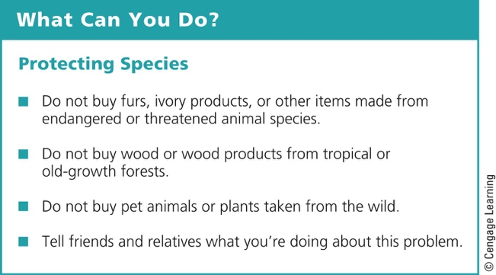

The Precautionary Principle
- Precautionary principle
  - Act to prevent or reduce harm when preliminary evidence indicates acting is needed
- Species are the primary components of biodiversity
- Should we focus on the preservation of species or the preservation of ecosystems?
Case Study: Protecting Honeybees and Other Pollinators
- Failure to protect honeybees
  - Loss of vital ecosystem services
- Farmers are:
  - Breeding bees resistant to harmful parasitic mites and fungi
  - Raising their own colonies
- Improving bee nutrition
Three Big Ideas
- We are hastening the extinction of wild species and degrading the ecosystem services they provide by:
  - Destroying and degrading habitats
  - Introducing harmful invasive species
  - Increasing human population growth, pollution, climate change, and overexploitation
- We should avoid causing the extinction of wild species
  - Species provide vital ecosystem and economic services
  - Their existence should not depend primarily on their usefulness to us
- We can work to prevent the extinction of species and to protect overall biodiversity and ecosystem services by:
  - Using laws and treaties
  - Protecting wildlife sanctuaries
  - Making greater use of the precautionary principle

