APES Chapter 15
Nonrenewable Energy

Core Case Study: Is the United States Entering a New Oil and Natural Gas Era?
- Oil and natural gas
  - Two most __________ __________ natural resources in the U.S.
- Oil consumption is ____________________
  - New extractions from ________ ____________ cause environmental harm
  - Burning oil and natural gas will continue adding ____________________ gases to the atmosphere
15-1 What is Net Energy and Why Is It Important?
- Energy resources vary greatly in their net energy __________
Net Energy Is the Only Energy That Really Counts
- Net energy yield
  - Total amount of ____________________ energy available from a resource minus the energy needed to make the energy ____________________ to consumers
- Energy return on ____________________
  - Energy ____________________ per unit energy __________ to obtain it
- First law of _________________________:
  - It takes high-quality energy to get high-quality energy
    - Pumping __________ from ground, refining it, and transporting it
- Second law of _________________________:
  - Some high-quality energy is ____________________ at every step
Some Energy Resources Need Help to ____________________ in the Marketplace
- Cannot compete in open ____________________ with alternatives that have higher net energy yields
  - Need ____________________ from taxpayers
- Nuclear power
  - The uranium fuel cycle is ____________________
15-2 What Are the Advantages and Disadvantages of Oil?
- Conventional __________ oil is abundant and has a medium net energy yield, but using it causes air and water ____________________ and releases greenhouse gases to the atmosphere
  - ____________________ heavy oil from oil shale rock and tar sands exists in potentially large supplies but has a low net energy yield and a higher environmental impact than conventional oil
We Depend Heavily on Oil
- Crude oil (____________________)
- Peak production – time after which production from a well ____________________
  - Global peak production for all world oil
- Crude oil ____________________ be used as it comes out of the ground
  - Must be ____________________
  - Petrochemicals – ____________________
Are We Running Out of Conventional Oil?
- Availability determined by:
  - ____________________
  - ____________________
  - Rate at which we ____________________ the oil
  - Cost of making oil ____________________
  - Market price
- Proven oil reserves – available deposits
  - ____________________
- Unconventional heavy oil
  - Higher ____________________ cost; ____________________ cost
- Three major options:
  - Live with much higher oil __________
  - Extend oil supplies ____________________
  - Use other energy sources
Use of Conventional Oil Has Environmental Costs
- Land disruption, greenhouse gas emission, air pollution, water pollution, and loss of biodiversity
- Burning oil accounts for ______ of global CO₂ emissions
_______________________________ _______________________________
_______________________________ _______________________________
_______________________________ _______________________________
_______________________________ _______________________________
_______________________________ _______________________________
Case Study: Oil Production and Consumption in the United States
- The U.S.:
  - Produces ______ of the world’s oil and uses ______ of world’s oil
  - Has about ______ of world’s proven oil reserves
  - Imports ______ of its oil
- Should we look for more oil reserves?
  - Extremely ____________________
  - ____________________ and financially risky
Heavy Oil from Oil Shale Rock
- Oil shales contain ____________________
  - After ____________________ – shale oil
- ______ of the world’s reserve is in arid areas of western United States
  - Locked up in rock
  - Lack of water needed for extraction and processing
  - Low net energy yield
_______________________________ _______________________________
_______________________________ _______________________________
_______________________________ _______________________________
_______________________________ _______________________________
_______________________________ _______________________________
Heavy Oil from Tar Sands
- Tar sand contains ____________________
- Extensive deposits in ____________________ and ____________________
  - Oil sands have more oil than in ____________________ ____________________
- ____________________
  - Serious environmental impact before ____________________-____________________
  - __________ net energy yield
15-3 What Are the Advantages and Disadvantages of Using Natural Gas?
- ____________________ natural gas:
  - Is more ____________________ than oil
  - Has a ____________________ net energy yield and a fairly low production cost
  - Is a __________-____________________ fuel
- However, producing it has created ____________________ problems
Natural Gas Is a Useful, Clean-Burning, but Not Problem-Free Fossil Fuel
- Natural gas – __________ methane __________
- Conventional natural gas
  - Liquefied ____________________ gas (LPG)
    - Stored in tanks
  - Liquefied ____________________ gas (LNG)
    - Low net energy yield
    - Makes U.S. dependent upon ____________________ countries like Russia and Iran

- The U.S. produces gas conventionally and from shale rock
  - Increasing environmental problems with shale rock ____________________
_______________________________ _______________________________
_______________________________ _______________________________
_______________________________ _______________________________
_______________________________ _______________________________
_______________________________ _______________________________
Case Study: Natural Gas Production and Fracking in the U.S.
- ____________________
  - Drilling wells; using huge amounts of water, sand, and chemicals; dealing with toxic wastewater; transporting the natural gas
- Drinking water ____________________ with natural gas can catch fire
- Fracking has several ____________________ environmental effects
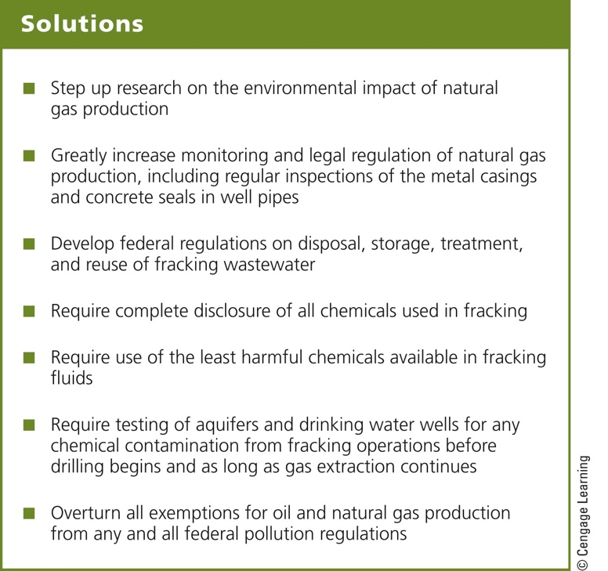
____________________ Natural Gas
- Coal bed methane gas
  - In coal beds near the earth’s surface; in shale beds
  - High environmental impacts of extraction
- Methane hydrate
  - Trapped in icy water; in permafrost environments; on ocean floor
  - Costs of extraction is currently too high
15-4 What Are the Advantages and Disadvantages of Coal?
- Conventional coal is ____________________ and has a __________ net energy yield at __________ costs, but using it results in a __________ __________ environmental impact
  - We can produce gaseous and liquid fuels from __________, but they have __________ net energy yields and using them would result in ______________ environmental impacts than those of conventional coal
Coal Is a Plentiful but Dirty Fuel
- Coal
  - ____________________ fossil fuel
- Burned in power plants
  - Generates ______ of the world’s electricity
- Abundant – world’s largest coal reserves
  - ____________________ ____________________
  - ____________________
  - ____________________
- Environmental costs of burning coal
  - Severe air pollution
    - Sulfur released as __________
    - Large amount of __________
    - __________
    - Trace amounts of ____________________ and radioactive materials
The Clean Coal Campaign
- Coal companies and energy companies have fought:
  - Classifying carbon dioxide as a ____________________
  - Classifying coal ash as ____________________ waste
  - Air pollution standards for ____________________
- The 2008 clean coal campaign
  - Note: there is no such thing as clean coal
_______________________________ _______________________________
_______________________________ _______________________________
_______________________________ _______________________________
_______________________________ _______________________________
_______________________________ _______________________________
We Can Convert Coal into Gaseous and Liquid Fuels
- Conversion of solid coal to:
  - Synthetic natural gas (SNG) by coal ____________________
  - Methanol or synthetic gasoline by coal ____________________
  - ____________________

- Are there benefits to using these ____________________ fuels?
_______________________________ _______________________________
_______________________________ _______________________________
_______________________________ _______________________________
_______________________________ _______________________________
_______________________________ _______________________________

15-5 What Are the Advantages and Disadvantages of Using Nuclear Power?
- Nuclear power has a __________ environmental impact and a very __________ accident risk, but its use has been limited by:
  - A low net energy __________, high __________, __________ of accidents, and long-lived radioactive _______________
  - Its role in spreading nuclear ____________________ technology
How Does a Nuclear Fission Reactor Work?
- ____________________ nuclear fission reaction in a reactor
  - Light-water reactors
  - Very inefficient
- Fueled by ____________________ ore and packed as pellets in fuel rods and fuel assemblies
- Control rods absorb ____________________
- Water is the usual coolant
- Containment shell around the core for protection
- Water-filled pools or dry casks for storage of radioactive spent fuel rod assemblies
What Is the Nuclear Fuel Cycle?
- Mine the uranium
- Process the uranium to make the fuel
- Use it in the reactor
- Safely store the radioactive waste
- Decommission the reactor
_______________________________ _______________________________
_______________________________ _______________________________
_______________________________ _______________________________
_______________________________ _______________________________
_______________________________ _______________________________
Storing Radioactive Spent-Fuel Rods Presents ____________________
- Rods must be replaced every three or four years
- Cooled in water-filled pools
- Placed in dry casks
- Must be stored for thousands of years
- Vulnerable to terrorist attack
Dealing with Radioactive Nuclear Wastes Is a Difficult Problem
- High-level radioactive wastes
  - Must be stored safely for ____________________-____________________ years
- Where can it be stored?
  - Deep burial: safest and cheapest option
  - Would any method of burial last long enough?
  - There is still no facility
  - Shooting it into space is too dangerous
- Plans in the U.S. to build a repository for high-level radioactive wastes in the Yucca Mountain desert region (Nevada)
- Many problems including:
  - Cost of __________ billion
  - Rock fractures
  - Earthquake zone
  - Decrease national security
- Dealing with old nuclear power plants:
  - ____________________ or retire the power plant
  - Dismantle the plant and safely store the ____________________ materials
  - Enclose the plant behind a physical barrier with full-time security until a storage facility has been built
  - Enclose the plant in a tomb
    - Monitor this for ____________________ of years
Can Nuclear Power Help Reduce Climate Change?
- Nuclear power plants – no CO₂ emission
- Nuclear fuel cycle – emits CO₂
- Opposing views on nuclear power
  - Nuclear power advocates
  - Oxford Research Group
- Need high rate of building new plants, and a storage facility for radioactive wastes
Experts ____________________ about the Future of Nuclear Power
- ____________________ of nuclear power:
  - Fund more research and development
  - Pilot-plant testing of potentially cheaper and safer reactors
  - Test breeder fission and nuclear fusion
- ____________________ of nuclear power:
  - Fund rapid development of energy efficient and renewable energy resources
- New technologies
  - Advanced Light Water Reactors
    - Safer
  - ____________________ based reactors
    - Less costly and safer
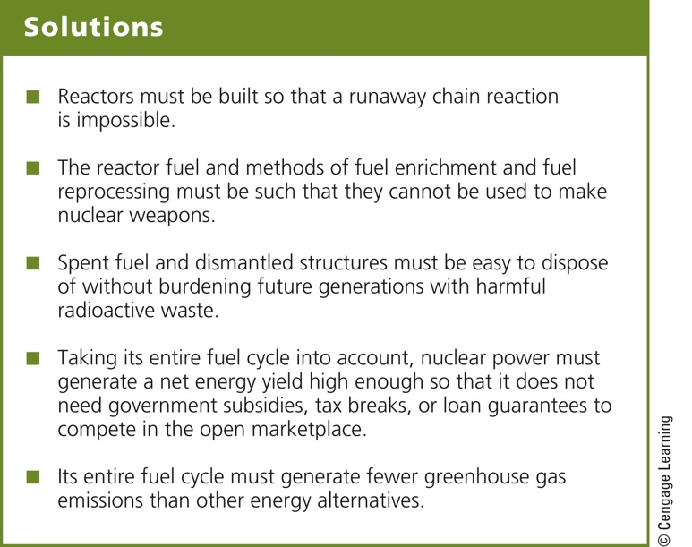
Case Study: The 2011 Nuclear Power Plant Accident in Japan
- Triggered by a major offshore ____________________ and resulting ____________________
- Four key human-related factors:
  - No worst-case scenarios
  - Seawalls too short
  - Design flaws
  - Relationship between plant owners and government
Is Nuclear Fusion the Answer?
- ____________________
  - Two isotopes fused together to form a heavier nucleus
  - Releases energy
- Technology is very difficult to ____________________
Three Big Ideas
- A key factor to consider in evaluating the long-term usefulness of any energy resource is its net energy yield
- Conventional oil, natural gas, and coal:
  - Plentiful and have moderate to high net energy yields
  - Use of these fossil fuels, especially coal, has a high environmental impact
- The nuclear power fuel cycle has a low environmental impact and a very low accident risk, but limited use because of:
  - High costs
  - A low net energy yield
  - Long-lived radioactive wastes
  - Its role in spreading nuclear weapons technology
Tying It All Together: A New U.S. Oil and Natural Gas Era and Sustainability
- Conventional fossil fuels have high net energy yields
- We cannot recycle energy
  - Recycling materials can help reduce energy needs
- Relying on a diversity of energy resources
  - Will reduce environmental impacts

