Chapter 6: Biomes
Section 1, What is a Biome?
What is a Biome?
- Biomes are large regions characterized by a ________________________________________________________________________________________________________________________________________________
- The ____________________________________________ of a region determines what type of biome can exist in that region.
- Each biome is made up of many individual __________________________________.
  - Communities within the biome have adapted to the small differences in climate and the environment inside the biome.
- Major biomes include deserts, forests, grasslands, tundra, and several types of aquatic environments.
More on Biomes
- All living things are ________________________________________ to their environment.
- Any change in one part of an environment, like an __________________________________________ of a species of animal or plant, causes a _____________________________________ of change in other parts of the environment.
- Remember, each organism depends in some way on other living and nonliving things in its surroundings.
To understand a world biome, you need to know the following:
- What the ___________________________________ of the region is like
- Where each biome is __________________________ and what its _________________________________ is like.
- The special ____________________________________ of the vegetation.
- The types of animals found in the biome and their _____________________________________________ adaptations to their environment.
Biomes and Vegetation
- Biomes are described by their __________________________________ because plants that grow in an area _______________________________________ that can live there.
- Plants in a particular biome have ________________________________________________________ that allow the plants to survive in that biome.
- These adaptations include _______________________________________________.
  - For example, plants in the tundra tend to be short because they cannot obtain enough water to grow larger.
Biomes and Climate
- __________________________________ is the average weather conditions in an area over a long period of time.
- Climate is the _________________________ factor is determining which plants can grow in a certain area, which in turn defines the biome.
- ________________________________________________________ are the two most important factors that determine a region’s climate.
Temperature and Precipitation
- Most organisms are adapted to live within a particular range of temperatures and will not survive at temperatures too far above or below their range.
- Precipitation also ____________________________the organisms that can be found in a biome because all organisms need water, and the bigger the animal, the more water it needs.
Temperature and Precipitation
- Biomes that do not receive enough rainfall to support large trees support communities __________________________________ by small trees, shrubs, and grasses.
- In biomes where rainfall is not frequent, the vegetation is mostly _______________________________________________.
- In extreme cases, _______________________________________ results in no plants, no matter what the temperature is.
- The ___________________________________ the temperature and precipitation are, the ___________________________________________ the vegetation is.
Latitude and Altitude
- _________________________________ is the distance north or south from the equator, and is expressed in degrees.
- _________________________________ is the height of an object above a reference point, such as sea level or the Earth’s surface.
- Climate _______________________________ with latitude and altitude.
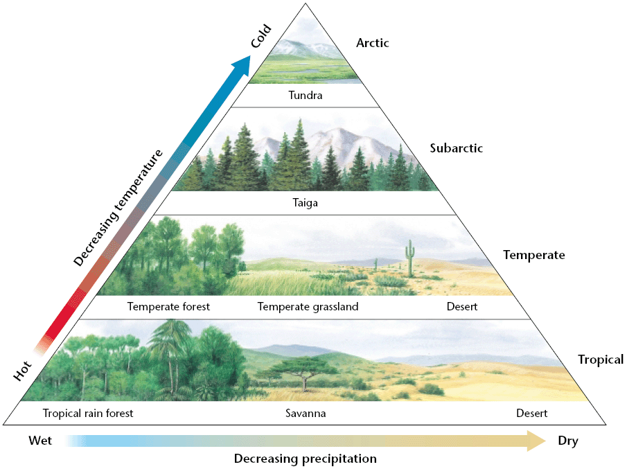
- For example, climate gets ___________________________ as latitude and altitude ___________________________. This is why it gets colder as you move further up a mountain.
Latitude and Altitude
- As latitude and altitude _____________________, biomes and vegetation _____________________.
- Trees of tropical rainforests usually grow closer to the _____________________, while mosses and lichen of the tundra grow closer to the _____________________.
- The temperate region includes biomes such as _________________________________________, which usually have moderate temperatures and fertile soil that is ideal for agriculture.

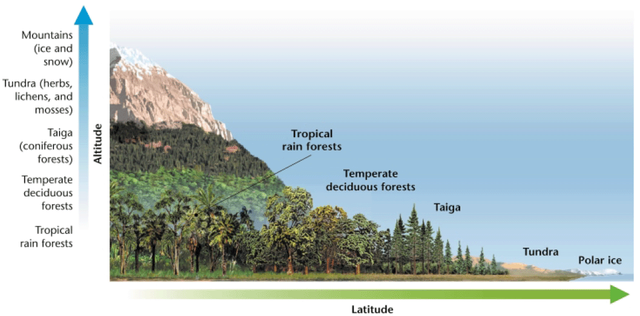

Chapter 6: Biomes
Section 2, Forest Biomes

Forest Biomes
- Of all the biomes in the world, __________________________________________ are the most widespread and the most diverse.
- The large trees of forests need a lot of water, so forests can be found where temperatures are __________________________________ and where rainfall is _____________________________________.
- There are three main forest biomes of the world: ______________________________________________________________________.
Tropical Rainforests
- _____________________________________________ are forests or jungles near the equator.
- They are characterized by _____________________________________________ and _________________________________________ in temperature and contain the greatest known diversity of organisms on Earth.
- They help regulate world climate an play vital roles in the _______________________________________________________________________.
- They are humid, warm, and get strong sunlight, which allows them to _______________________________________________________________________ that is ideal for a wide variety of plants and animals.
Nutrients in Tropical Rainforests
- Most nutrients are within the ______________________________, not the soil.
- Decomposers on the rainforest floor ________________________________________ and ________________________________________________________, but plants quickly absorb the nutrients.
- Some trees in the tropical rain forest support _______________________ that feed on dead organic matter on the rainforest floor.
- In this relationship, the fungi ___________________________________ the nutrients from the dead matter directly to the tree.
Nutrients in Tropical Rainforests
- Nutrients from dead organic matter are removed so efficiently that runoff from rain forests is often as _______________________________________________________.
- Most tropical soils that are cleared of plants for ______________________________________________________________________ for more than a few years.
- Many of the trees form above ground roots called _____________________________________________________ that grow sideways from the tree to provide it with _____________________________________ in the thin soil.
Layers of the Rainforest
- In tropical rain forests, different types of plants grow in different layers.
- There are _______________________ main layers of the rain forest:
  - _______________________________________
  - _______________________________________
  - _______________________________________
  - _______________________________________
Layers of the Rainforest
- The _______________________________________________ is the top foliage layer in a forest where the trees extend above surrounding trees.
- Trees in this layer grow and emerge into ______________________________________ reaching heights of ________________________________ and can measure up to 5 m around.
- Animals such as eagles, bats, monkeys, and snakes live in the emergent layer.
Layers of the Rainforest
- The ____________________________________ is the layers of treetops that ____________________________ the forest floor, and is considered to be the _________________________________________ of the rain forest.
- The tall trees, more than 30 m tall, form a dense layer that absorbs up to _________________________________ of the sunlight.
- The canopy can be split into and ___________________________________ canopy with the lower canopy receiving less of the sunlight.
Layers of the Rainforest
- ________________________________________ are plants that use another plant for support but not for nourishment, and are located on high trees in the canopy.
- Growing on tall trees allows them to __________________________________________ needed for photosynthesis, and to _______________________________________________________________ that run down the tree after it rains.
- Most animals that live in the rain forest live in the canopy because they depend on the _________________________________________________ that grow there.
Layers of the Rainforest
- The _______________________________________ is the foliage layer that is beneath and shaded by the main canopy of a forest.
- ___________________________________________ reaches this layer allowing only trees and shrubs adapted to shade to grow there.
- Most plants in the understory do not grow more that _____________________________.
- __________________________ with large flat leaves that grow on the forest floor capture the small amount of light that penetrates the understory.
Species Diversity
- The diversity of rainforest vegetation has led to the _____________________________ of a diverse community of animals.
- Most rainforest animals are _________________________________ that use specific resources in particular ways to avoid ___________________________ and have adapted amazing ways to capture prey and avoid predators.
- Insects use ____________________________ to avoid predators and may be shaped like leaves or twigs.
Threats to Rainforests
- Every minute of every day, ________________________ acres of tropical rainforest are cleared for _______________________________________________________________________.
- Exotic pet trading robs the rain forests of rare and valuable plant and animal species only found there.
- ____________________________________________ occurs when land inhabited by an organism is destroyed or altered.
- If the habitat that an organism depends on is destroyed, the organism is at risk of disappearing.
Threats to Rainforests
- An estimated _________________________________ native peoples live in tropical rain forests and are also threatened by habitat destruction.
- Because they obtain nearly everything they need form the forest, the loss of their habitat could force them to leave their homes and move into cities.
- This drastic change of lifestyle may then cause the native peoples too lose their culture and traditions.
Temperate Forests
- ___________________________________________________ are forests communities that are characterized by
  - ________________________________________________________________
  - ________________________________________________________________
  - ________________________________________________________________
  - ________________________________________________________________
- They occur in North America, Australia, and New Zealand, and are dominated by evergreen trees such as the ________________________________________________.
Temperate Deciduous Forests
- _______________________________________________ are forests characterized by trees that _____________________________________________ in the fall, and located between 30º and 50º north latitude.
- The range of temperatures can be extreme, with summer temperatures soaring to 35ºC and winter temperatures often falling below freezing.
- They receive _______________________________ of precipitation annually, which helps to decompose dead organic matter contributing to the rich soils of the forest.

Plants of Deciduous Forests
- Plants in the deciduous forests grow in _______________________________ with tall trees, such as ___________________________, dominating the __________________ while shrubs cover the _________________________________.
- Also, _______________________________ reaches deciduous forest floors than rain forests floors allowing more plants to grow.
- Temperate forest plants are _____________________________ to survive seasonal changes.
- In the fall and winter, trees _____________________ their leaves and seeds go ___________________________________ under the insulation of the soil.
- With the returning warmth in the spring, the trees grow new leaves and seeds germinate.
Animals of Deciduous Forests
- The animals of temperate deciduous forests are adapted to use the forest plants for both _____________________________________________.
- Birds cannot survive the harsh winter of the deciduous forests so each fall they ___________________________________ for warmer weather and better availability of food.
- Other animals, such as mammals and insects, _______________________________________________________ so that they do not need as much food for energy, enabling them to survive the winter.
Taiga
- The ___________________________________ is the region of ___________________________________________________________ below the arctic and subarctic tundra regions.
- The taiga has long winters and little vegetation.
- The growing season can be as short as ______________________________ with most plant growth occurring during the summer months because of nearly constant daylight and larger amounts of precipitation.
Plants of the Taiga
- A ______________________________________ is a tree that has seeds that develop in cones.
- Their leaves’ ____________________________________________________ helps them to retain water in the winter.
- The conifer’s shape also helps the tree _________________________________ to the ground and not get weighed down.
- Conifer needles contains substances that make the soil __________________________ when they fall to the ground preventing plants from growing on the floor.
- Also, soil forms slowly in the taiga because the climate and acidity ________________ decomposition.
Animals of the Taiga
- The taiga has many ____________________________________ that in the summer attract birds that feed on insects.
- To avoid the harsh winters, birds _____________________________, while some year round residents, such as shrews, burrow underground for better insulation.
- Other animals, such as snowshoe hares, have adapted to avoid predation by shedding their brown summer fur and growing white fur that camouflages them in the winter snow.

Chapter 6: Biomes
Section 3, Grasslands, Deserts, and Tundra
Grassland, Desert, and Tundra Biomes
- In climates that have less rainfall, forest biomes are replaced by _____________________________________________________________________________
- As even less rain falls in these biomes, they change into desert and tundra biomes.
- As precipitation ________________________________________ in an area, the diversity of the species in the area also _________________________________________.
- But, the number of individuals of each species present may still be very large.
Savannas
- _____________________________________ are plains full of grasses and scattered trees and shrubs that are found in ___________________________________________________________________.
- Found mainly in regions with a __________________________________, such as East Africa and western India.
- Although savannas receive little precipitation throughout the year, they do have a _________________________________________________________________________________.
- Many animals are only active during the wet season.
- ________________________________________ help to restore nutrients to the soil during the dry season.
Plants of the Savanna
- Because most of the rain falls during the wet season, plants must be able to survive prolonged periods without water.
- Some plants have large _______________________________________________ to help them survive the dry season.
- These roots also enable the plant to grow _________________________________ after a fire.
- The grasses also have ________________________________________________ that expose ____________________________________________________ to help conserve water, while some trees shed their leaves.
- Almost all have _____________________________ for protection from herbivores.
Animals of the Savanna
- ____________________________________________, like the elephant, have adopted migratory ways of life, following the rains to areas of new grass and fresh watering holes.
- Predators often stalk these animals for food.
- Many savanna animals give birth only during the _________________________________, when food is abundant and the young are more likely to survive.
- Some species of herbivores reduce competition for food by _____________________________________________ at different heights than other species do.
Temperate Grasslands
- _______________________________________________ are communities (or biomes) that are dominated by grasses, have few trees, and are characterized by _________________________________________________________, with rainfall that is intermediate between that of a forest and a desert.
- Temperate grasslands have the ________________________________________ soil of any biome.
- Few natural temperate grasslands remain because many have been replaced by _____________________________________________ and farms growing crops such as corn, soybeans, and wheat.
Temperate Grasslands
- Temperate grasslands are located on the interiors of continents where too little rain falls for trees to grow and include the prairies of North America.
- _____________________________________ often play a crucial role in maintaining grasslands as rain clouds from the west are blocked.
- However, rainfall does increase as you move eastward, allowing taller grasses to grow.
- Heavy precipitation is __________________________________ in the grasslands, allowing the hot temperatures in the summer to make the grasslands ______________________________________.
Plants of Temperate Grasslands
- The roots system of prairie grasses form _________________________________________ that survive ______________________________________________ allowing the plants to come back from year to year.
- Few trees survive on the grasslands because of the lack of rainfall, fire, and the constant winds.
- The __________________________________________ in the area determines the types of plants that will grow in that area with varying root depth and grass height.
Animals of Temperate Grasslands
- Some grazing animals, such as the bison and pronghorn antelope, have ________________________________________________ for chewing the coarse prairie grasses.
- Other grasslands animals, such as prairie dogs, owls, and badgers, live protected in underground burrows that protect them from predators on the open grasslands.
Threats to Temperate Grasslands
- ____________________________________________________ have changed the grasslands.
- ____________________________________________________ cannot hold the soil in place as well as native grasses can because the roots of crops are shallow, so ___________________________________ eventually occurs.
- ___________________________________________ is also caused as the grasses are constantly eaten and trampled.
- Constant use can change the fruitful grasslands into desert like biomes.
Chaparral
- _________________________________________ is a type of ______________________________________________________ biome with vegetation that includes broad-leafed evergreen shrubs and is located in areas with hot, dry summers and mild, wet winters.
- Chaparrals are located in the middle latitudes, about 30° north and south of the equator.
- Chaparrals are located primarily in coastal areas that have _________________________________ climates.
Plants of the Chaparral
- Most chaparral plants are low-lying, _________________________________________________________________ that tend to grow in dense patches and include chamise, manzanita, scrub oak, and herbs like sage and bay.
- These plants have ____________________________________________________ that contain oils that promote burning, allowing _____________________________________________ to destroy competing trees.
- Chaparral plants are well adapted to ____________________________________________ from small bits of surviving plant tissue.
Animals of the Chaparral
- A common adaptation of chaparral animals is _____________________________________, shape or coloring that allows an animal to blend into its environment.
- Animals such as quail, lizards, chipmunks, and mule deer have a brownish gray coloring that lets them move through the brush without being noticed.
Threats to the Chaparral
- Worldwide, the greatest threat to chaparral is ______________________________________________.
- Humans tend to develop lands of the chaparral for ______________________________________________________________ because these biomes get a lot of sun, are near the oceans, and have a mild climate year round.
Deserts
- ______________________________________ are regions that have little or no vegetation, long periods without rain, and extreme temperatures.
- Although there are hot and cold deserts, one characteristic they both share is the fact that they are the ______________________________________________ on Earth.
- Deserts are often located near large mountain ranges because mountains can block the passage of moisture-filled clouds, limiting precipitation.
Plants of the Desert
- All desert plants have __________________________________________ for obtaining and conserving water, which allows the plants to live in dry, desert conditions.
- Plants called ________________________________________, such as cactuses, have thick, fleshy stems and leaves that conserve water.
- Their leaves also have a _____________________________________________ to prevent water loss, while sharp spines on the plant keep animals away.
- Many plant roots spread out just under the surface to absorb as much rain as possible.
Plants of the Desert
- Some plants are adapted to survive for long periods ________________________________________________.
- When conditions are too dry, these plants ______________________________________ their seeds that stay dormant until the next rainfall.
- Then, new plants quickly germinate, grow, and bloom before the soil becomes dry again.
- These plants can survive their water content dropping to as low as 30 percent of their mass.
Animals of the Desert
- Animals of the desert have adapted many different ways to prevent ___________________________.
- _____________________________________________ have thick, scaly skin that prevents water loss.
- Amphibians survive by _________________________________, or burying themselves in the ground and sleeping through the dry season.
- Insects are covered with _____________________________________ that helps them ________________________________________________.
- In addition, most desert animals are ____________________________________, meaning they are active mainly at night or dusk when it is cooler.
Tundra
- The _____________________________________ is a treeless plain that is located in the _________________________________________________________________ and that is characterized by very low winter temperatures, short, cool summers, and vegetation that consists of grasses, lichens, and perennial herbs.
- Summers are short in the tundra, so only the top few centimeters of soil thaw.
- _________________________________________ is the permanently frozen layer of soil or subsoil and can be found in the tundra regions.
Vegetation of the Tundra
- ___________________________________________________, which can grow without soil, cover vast areas of rocks in the tundra.
- The soil is thin, so plants have _______________________________________ to help anchor them against the icy winds.
- Most flowering plants are _________________________________, which keeps them out of the wind and helps them ______________________________________________ from the sunlit soil.
- Woody plants and perennials have evolved ___________________________________ that grow flat along the ground.
Animals of the Tundra
- Millions of migratory birds fly to the tundra to ________________________ in the summer when food is abundant.
- Caribou migrate throughout the tundra in search of food and water.
- Hunters such as wolves prey on migratory caribou, deer, and moose.
- Rodents stay active, but burrow underground to avoid the cold.
- Other year-round residents, such as arctic foxes, lose their brown summer coat for white fur that _____________________________________ them with the snow.
Threats to the Tundra
- The tundra is one of the most _______________________________________ biomes on the planet.
- The food chains are relatively simple so they are easily disrupted.
- Until recently these areas have been __________________________________________ by humans
- But oil was located in parts of the tundra, and oil exploration, extraction, and transport has disrupted many tundra habitats.
- Pollution caused by spills or leaks of oil and other toxic materials may also poison the food and water sources of organisms of the tundra.

